**Assignment-3**

**Data Manipulation (DML)-II:**

1. Count the total number of orders.

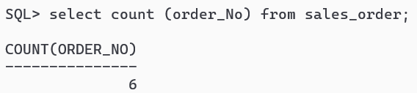

2. Calculate the average sale price of all the products.

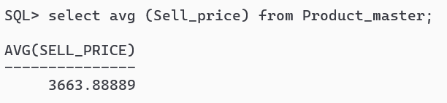

3. Count the number of products having price greater than or equal to 1500.

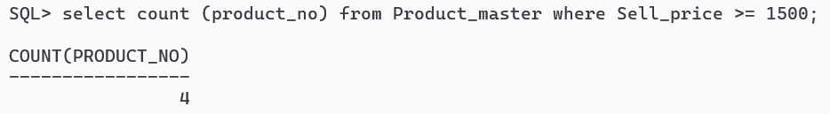

4. Determine the maximum and minimum product prices. Rename the output as max_price and min_price

respectively.

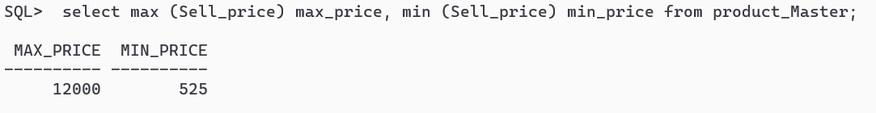

**5. Create the following tables and insert the data as mentioned below:**

**a) Emp table**

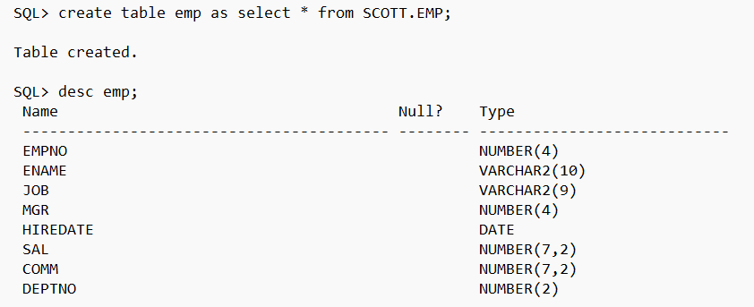

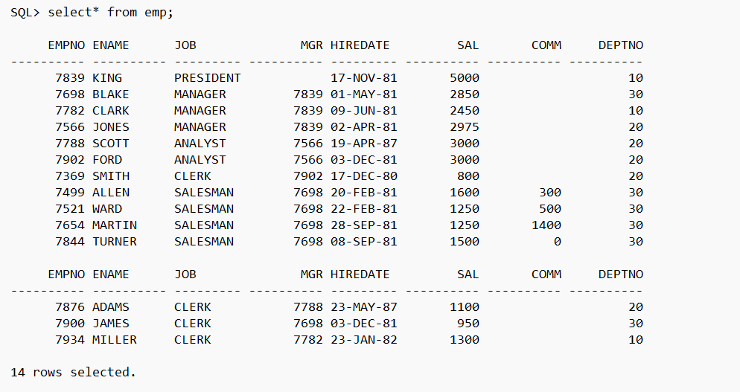

**b) Dept table:**

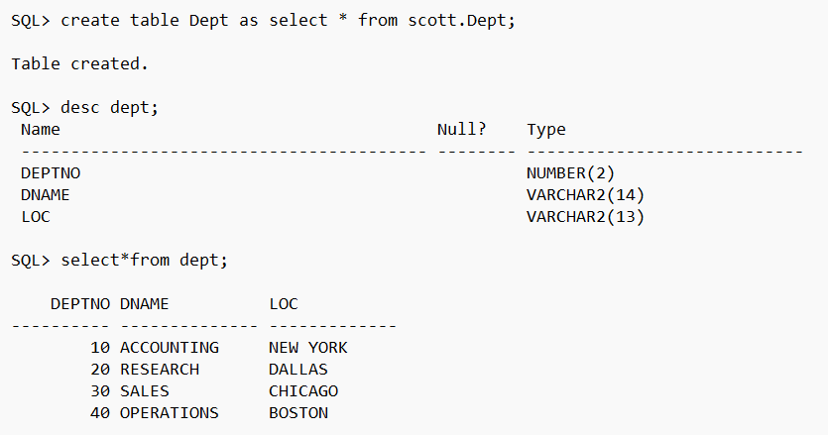

**c) Salgrade table**

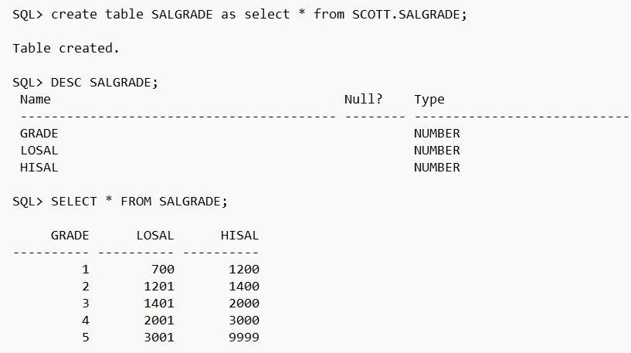

**6. Solve the following SQL (DML) query use Emp and Dept table created above**

a) List all department no, employee no, manager no. from emp table.

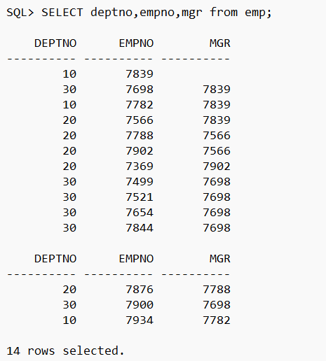

b) List all department name and location from dept table.

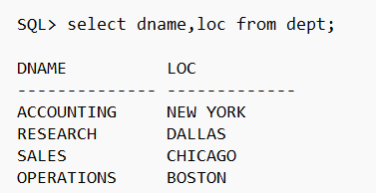

c) List the employees belong to the department 20.

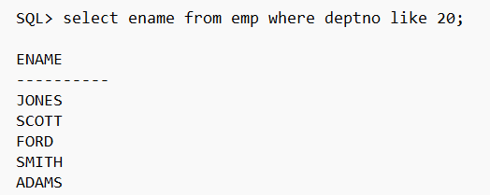

d) List the name and salary of the employee whose salary is more than 2500.

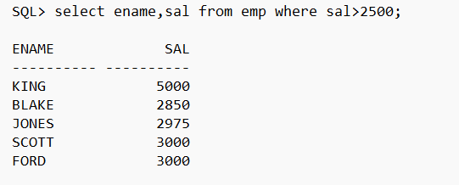

e) List the details of the employee who have joined before end of July 81.

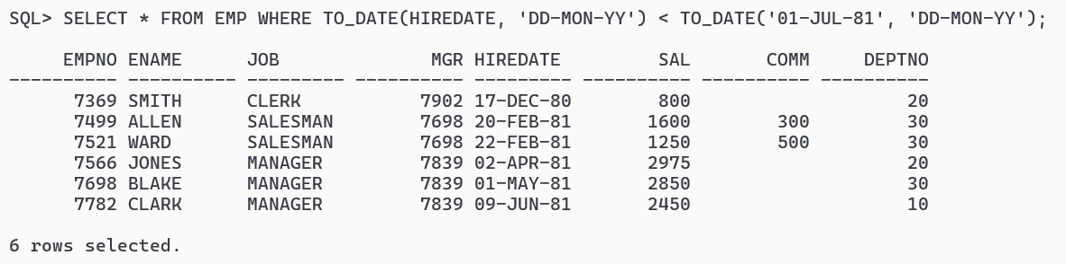

f) List the name of the employees who are not manager.

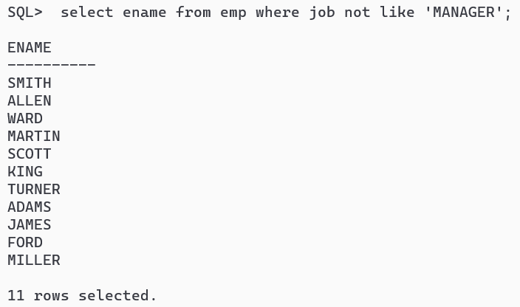

g) List the name of employees whose name end with ‘S’.

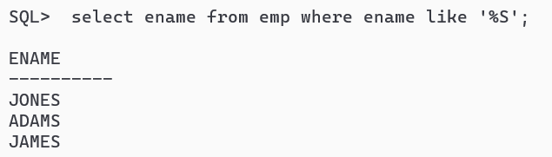

h) List the name of employees whose name has exactly 5 characters long.

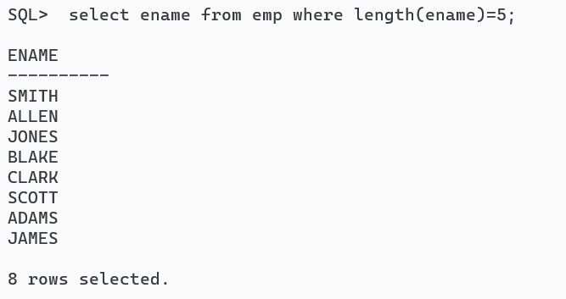

i) List the name of employees whose name having ‘R’ as the third character.

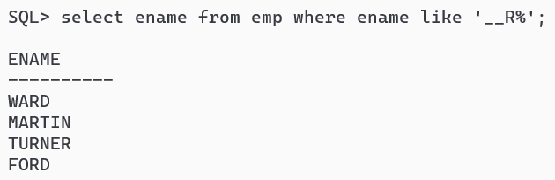

j) List all employee names and their salaries, whose salary lies between 1500/- and 3500/- both inclusive.

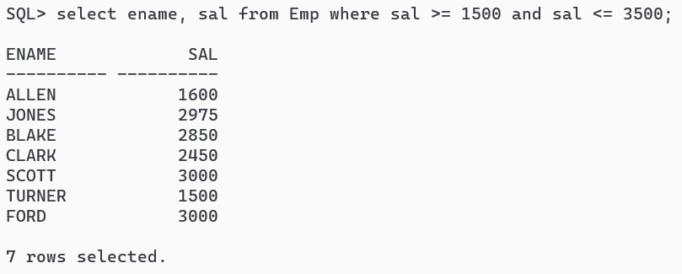

k) List all employee names and their and their manager whose manager is 7902 or 7566 0r 7789.

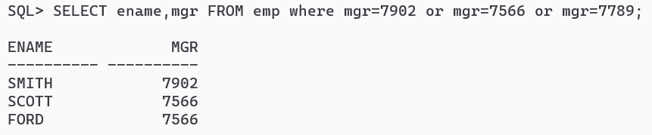

l) List all employees which start with either J or T.

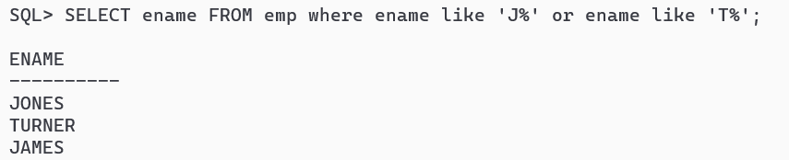

m) List all employee names and jobs, whose job title includes M or P.

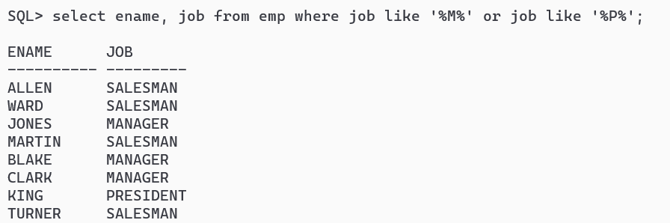

n) List all jobs available in employee table.

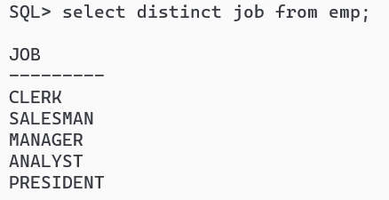

o) List all employees who belong to the department 10 or 20.

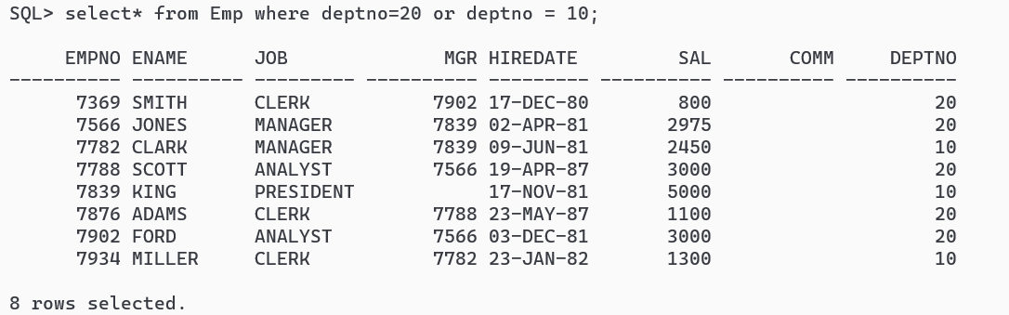

p) List all employee names, salary and 15% raise in salary.

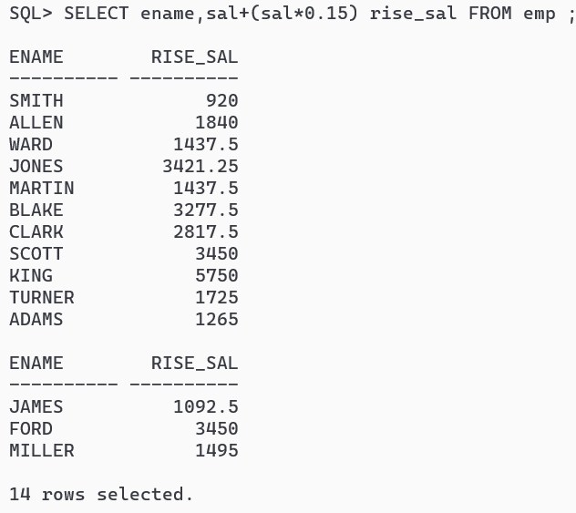

q) List minimum, maximum, average salaries of employee.

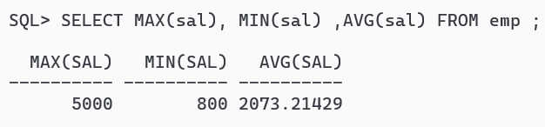

r) Find how many job titles are available in employee table.

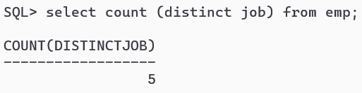

s) What is the difference between maximum and minimum salaries of employees in the organization?

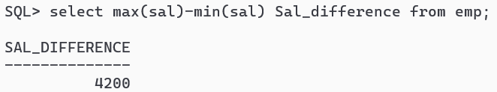

t) Find how much amount the company is spending towards salaries.

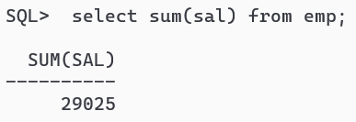

u) Display name of employees with deptno. 20.

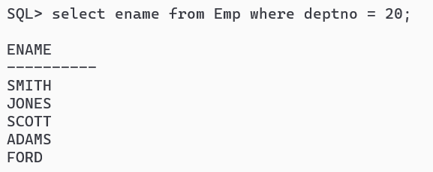

v) List ename who are not eligible for commission.

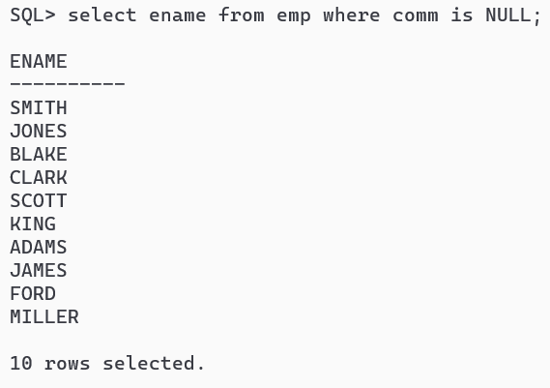

w) Find no.of dept in employee table.

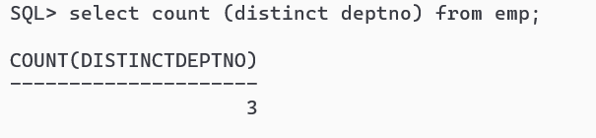

x) List ename and designation of the employee who does not report to anybody..

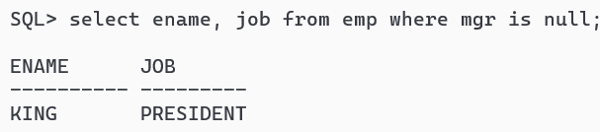

y) List the name of the employees who are less than 38 years old in the organization with respect to today’s date.

